Visual Walkabout

When someone has a true passion for something, they should always chase that dream and do what it takes to make it in that industry. There is no point in living this life if I'm not doing what I love. Sports Media is something I'm not only interested in but obsessed with. I follow every mainstream sports reporter and have their notifications on. I keep up with all the news and stories. This is what makes me happy. I truly enjoy sitting behind my laptop and reading a story about how an athlete's new contract will affect the team and the culture and all that. I love digging deep and talking to other people about how certain events happening will lead to more down the road and how that will affect the game. I just truly love sports and want to have an impact on sports and make it a better place.

There are many people who do make the industry a better and more positive space for the athletes. Those are the people I strive to be like with my work in the field. There is a happy medium that must be met, between the fans who rely on me to give them the news on their favorite athletes and the athletes themselves. They deal with tons of liars and cheats daily putting out fake narratives about them for their own personal gain. I will strive to be a bright spot in the industry for everyone involved.

I also will need to build a team. I don’t want to do this alone. I believe if someone wants to be truly special at something, they will need to be able to accept help from other with the same goals. This is what The Pat Mcafee Show has done. Pat, former NFL ALL-Pro Punter and comedian has a daily show with a few of his buddies that reports the truth and is incredibly genuine to the athletes they deal with.

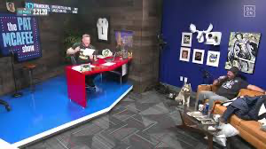

The power of a single microphone is something people do not talk about enough. One person saying false narratives into a microphone can not only change their life but can also change the athletes or coaches lives as well. Many people believe everything they hear regardless of how sketchy the person dealing the information might be. This leads to lies being spread about people and this can very negatively affect the other parties' careers. This is why I believe if you are saying something into a microphone for others to hear, it better true what you are saying.

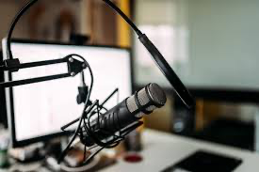

Another aspect of the sports media world that gets overlooked is the fact that many of the people you see on television everyday talking about your favorite athletes, have never even spoken to the athletes they make millions talking about. All they speak are narratives and stories they hear from other people who may or may not have a personal relationship with the athletes. My goal in the industry is to make personal relationships with the athletes and build a common trust between us to where when I report something about the athlete, I comes straight from the source themselves. This will lead to even more athletes and coaches trusting me with personal info they might not share to other reporters they don’t trust quite as much. Having good ties with big people in the industry would benefit anyone trying to spread the word. A good reputation is the most important step to becoming a good sports reporter. If people see you as a rat, or someone who simply can't be trusted, they will never help you out or give you important information. Men like Ian Rapaport or Adrian Wojnarowski or women like Charrissa Thompson or Doris Burke all are very well respected in their own fields and sports. These are also the same people who break the biggest stories and make the most money. This isn't a coincidence.

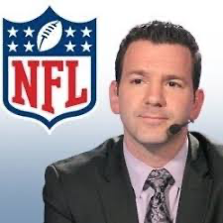

All in all, being an all-around good person and being honest with not only the fans but the athletes is the best trait a member of the sports media can have. It will lead more strong connections and relationships with the very people their whole livelihoods depend on.